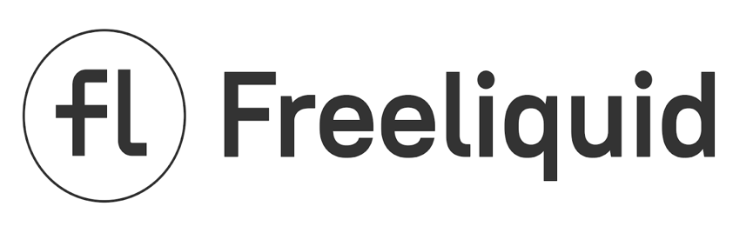

**The Freeliquid Protocol**

White Paper

<https://freeliquid.io/>

Version 1.1: October 2020

**Abstract**

Freeliquid Protocol is an open-source platform built on the Ethereum blockchain. It serves as a decentralized finance protocol that offers borrowing and savings programs to crypto asset holders. One of the innovative features of Freeliquid is the ability to receive USD stablecoins for providing liquidity pools (e.g., from Uniswap) as collateral. Pools that are locked on Freeliquid remain fully functional and continue to earn commission fees on their native platforms. Borrowed funds can be used for any purposes, such as creating more liquidity pools, thereby significantly increasing user profits. The USDFL token is Freeliquid’s native stablecoin, which is soft-pegged to the US dollar. FL serves as the governance token used in Freeliquid Voting. Both FL and USDFL tokens operate on the ERC-20 standard. The Fair Launch model implies a distribution of the initial FL tokens through reward programs. Freeliquid users play a defining part in the development of the Protocol through community work and proposal voting.

**Table of Contents**

1. Introduction 3

2. The Freeliquid Protocol 4

2.1 General information 4

2.2 Freeliquid Borrow 5

The USDFL stablecoin 5

Freeliquid Vaults 5

Working example 6

2.3 Freeliquid Save 7

2.4 Freeliquid Reserve 7

2.5 Oracles 8

3. Freeliquid Governance 9

3.1 FL governance token 9

3.2 Freeliquid Voting 9

3.3 FL token issuance 9

FL issuance charts 11

4. Emergency Shutdown 13

# 1. Introduction

One of the most popular trends of the cryptocurrency industry in the year 2020 have been DeFi projects – solutions and protocols for decentralized finance. Among the many benefits that DeFi offers, two services stand out – using liquidity pools to facilitate coin exchange between users and offering loans with crypto assets as serving as security. Until now, these services lacked a connection, as existing lending platforms do not accept liquidity pools as collaterals. Freeliquid’s developer team has decided to change this.

The Freeliquid Protocol enables users to receive USD stablecoins by locking liquidity pools as collaterals. The main advantage of this solution is that investors can now get extra funding, while keeping the passive income from the liquidity provider fees. The newly-obtained stablecoins can be used to increase the size of the existing liquidity pool or create another one. The process can be repeated several times, effectively leveraging the initial investment with no risks. Alternatively, the funds can be used for any other purpose, such as trading or yield farming. In any case, Freeliquid users can therefore turn their liquidity pools into a source of extra funding, potentially multiplying their profits.

The Freeliquid developer team firmly believes in the principles of decentralized peer-to-peer networks. The Freeliquid Protocol will be governed by its community through the FL governance token for voting (see Chapter 3). To fairly distribute the voting power inside the community, the initially generated FL tokens will not be held by the developers or offered through an initial coin offering (ICO). Instead, the FL tokens will be distributed *only* as rewards for actively using the Freeliquid platform or for providing liquidity to the native tokens of Freeliquid.

This white paper presents a thorough overview of the Freeliquid project.

Readers who are interested in the technological underpinnings are welcome to go through the [code](https://github.com/Freeliquid/) of the Freeliquid smart contracts.

# 2. The Freeliquid Protocol

## 2.1 General information

The Freeliquid Protocol is a fork of the MakerDAO platform. The main operating principles of Freeliquid are completely identical to MakerDAO smart contracts (see [Maker documentation](https://makerdao.com/en/whitepaper/)). The decision to use the proven MakerDAO framework has been made to ensure security, transparency, and efficiency of the Freeliquid Protocol. The chosen framework also contains a well-designed governance system, which relies on community-driven voting using a governance token.

The Freeliquid Protocol operates on the Ethereum blockchain. The Protocol’s entire codebase is available as open source on [Github](https://github.com/Freeliquid/). The web platform is currently hosted at <https://freeliquid.io/> and can be accessed by connecting a crypto wallet, such as Metamask or Ledger Nano.

The Freeliquid Protocol has been developed by a group of enthusiasts, who continue to support and further develop the project. The decision-making, however, is mainly done by the decentralized community of Freeliquid users. The changes to the Protocol are proposed and voted on by the community using the FL governance token (see Chapter 3.1), while the developer team remains responsible with implementing decisions.

## 2.2 Freeliquid Borrow

Freeliquid Borrow enables its users to lock crypto assets in the form of liquidity pools as collateral to borrow USDFL stablecoins. We first give an overview of the USDFL stablecoin and then describe how the borrowing process works.

### The USDFL stablecoin

USD Freeliquid (USDFL) is an ERC-20 stablecoin, which is soft-pegged to the US dollar. Its value is backed by user-provided collateral.

The USDFL token serves as the main currency of Freeliquid Protocol and has all proper functions of sound money, namely:

- a unit of account;

- a medium of exchange;

- a store of value with a stable market price;

- a standard of deferred payment.

As any other ERC-20 token, USDFL is easy to hold and transfer by using cryptocurrency wallets. USDFL can also be traded on decentralized exchanges, where users will be providing the respective liquidity pairs.

### Freeliquid Vaults

Freeliquid Vaults are smart contracts that generate USDFL after users lock collaterals in Freeliquid Borrow and specify their preferred loan size. Initially, only pools consisting of stablecoin pairs will be accepted as possible collateral. Additional collateral types can be added later through community voting.

Users can borrow USDFL in an amount of up to 90% of the collateralized asset value. The borrowed USDFL tokens constitute the outstanding Vault debt which is charged with an interest rate (‘Stability Fee’), displayed in annual terms. Initially, to support the early growth of the Freeliquid Borrow, the Stability Fees for each collateral type are set to zero. The maximum borrow amount percentage and Stability Fees may be changed later by the community to ensure the financial stability of Freeliquid. Note that these parameters are applied to each liquidity pair independently. Collected Stability Fees are stored in the Freeliquid Reserve (see Chapter 2.4).

The loans do not require an approval from a third party and are not restricted by any repayment date. Borrowing is processed instantly and can be repaid at any time by covering the outstanding amount of USDFL back to Freeliquid Borrow. It is always possible to only repay a portion of the outstanding debt or to generate additional USDFL, if the collateral provided is large enough.

Since the volatility of stablecoins and the risk of extreme price surges are very low, the liquidation module is switched off completely, meaning that liquidation is not possible. In the future, pairs with more volatile assets will be added to Freeliquid as possible collateral types. To account for potential risks, the liquidation function, which is already available for smart contracts, can be introduced through governance voting.

### Working example

To better illustrate how Freeliquid Borrow works, consider the following example:

* Assume there is a liquidity provider (further called “the LP”) who has a USDT/USDC pool on Uniswap, which earns them a passive income in the form of liquidity provider fees.
* The LP’s position has the total value of both tokens locked. Let us take this value to be equal to 100,000 USD as an example.
* By using Freeliquid Borrow, the LP can lock his liquidity tokens as a collateral and receive up to 90% of the pool’s total value in the USDFL stablecoin. In our example, that would be approx. 90,000 USDFL, which could be immediately issued for the borrower.
* The LP now can use the obtained funds for their own purposes, such as exchanging USDFL for USDT/USDC and creating another liquidity pool on Uniswap with a total value of $90,000. In the end, the LP will hold a liquidity pool of $190,000 in total, which almost doubles the income from liquidity provider fees, while taking almost no risks.
* Alternatively, the borrowed funds can be used for trading or investing in crypto assets. This might bring much larger returns on the initial Vault value, but also entails higher risks.

## 2.3 Freeliquid Save

The USDFL Savings Rate (USDFLSR) is a component of the Freeliquid Protocol that enables users to lock USDFL and receive yields on their investment. Users can deposit (withdraw) their USDFL to (from) USDFLSR at any time and without any restrictions by only paying the Ethereum network fees. The funds for paying the Savings Rate yields come from Stability Fee earnings (see Chapter 2.2). Since Stability Fees are not charged at the early stage of Freeliquid, the Savings Rate will be initially set to zero.

After the USDFL tokens are locked in Freeliquid Save, earned USDFL are continuously generated and accrued to the user's balance. The accumulated profits for the past time can be claimed at any time. The current yield rate is susceptible to change through the means of community voting.

The profits from the Savings Rate can be calculated using the following formula:

$$A=P{(1+r)}^{t}$$

where:

A = final deposit value;

P = invested deposit value;

r = annual yield rate (determined through voting by FL holders);

t = number of years, during which the deposit remains in USDFLSR.

## 2.4 Freeliquid Reserve

The Freeliquid Reserve contains USDFL acquired from the revenues of the Freeliquid Platform. The Freeliquid Reserve is fully controlled by smart contracts and belongs neither to the developer team, nor to any user.

Freeliquid Reserve funding comes from the difference between revenue flows from Stability Fees (earned by the protocol in Freeliquid Borrow) and the Savings Rate (paid by the protocol in Freeliquid Save). The earned USDFL are used for the buyback of FL tokens from users via auctions. After the auction is closed following the best bid, the FL tokens bought from users are burned, effectively reducing the supply of FL.

## 2.5 Oracles

In all financial operations on the Freeliquid Platform, crypto asset prices are derived from Price Oracles. As in MakerDAO, Oracles consist of a decentralized network of individual external nodes called Oracle Feeds. Every user can initiate a transaction by paying the Ethereum network fees and thus updating Oracle prices on the Freeliquid platform. To cover the transaction costs and incentivize users to use Oracles, a total of 50,000 FL tokens will be reserved as rewards (see Chapter 3.3). Transaction initiators will receive FL rewards after each price update from the Oracles, but not more than once an hour.

At the time of the launch of Freeliquid, the prices of USDC, USDN, and DAI stablecoins, which are used in calculating collateral value, are assumed to be exactly equal to 1 US dollar. The price of USDT will be calculated by using Chainlink‘s decentralized Oracles.

# 3. Freeliquid Governance

The decentralization of the governance structure is one of the highest priorities of the Freeliquid project. While the Freeliquid developer team will continue to fully support the project, the decision-making about the current and future operations of Freeliquid belongs to the user community.

In this chapter, we describe the functionality of FL, as well as the voting process.

## 3.1 FL governance token

FL is Freeliquid’s governance token, built on the ERC-20 standard. Holders of FL are eligible to participate in the governance of the project through voting. As with the USDFL token, the FL can be stored on or transferred to any ERC-20 wallet, as well as traded on decentralized exchanges.

Users will be rewarded for providing liquidity pools for the FL/USDFL pair (see Chapter 3.3). As described in Chapter 2.4, the supply of FL tokens will be additionally decreased through Auctions, where users can receive USDFL for selling FL tokens, which are consequently burned.

## 3.2 Freeliquid Voting

FL tokens holders have the right to vote for changes in the Freeliquid protocol. To access our governance portal, users need to lock their FL tokens by transferring them to the Voting Contract. To cast a vote, simply send one transaction.

Every user is eligible to propose changes to facilitate further development of the decentralized structure of Freeliquid, but only FL holders can cast votes. After a vote is successfully carried out, the changes are implemented over a short course of time. For further technical details on how voting works, please refer to the following MakerDAO [documentation](https://makerdao.com/en/whitepaper/#use-of-the-mkr-token-in-maker-governance).

Through voting, FL token holders are eligible to:

- add new collateral types with custom risk parameters;

- add new risk parameters or change the existing ones;

- modify interest rates for the USDFL Savings Rate;

- determine the group of Oracles that supply the prices;

- execute the Emergency Shutdown of the system;

- adjust the parameters of different types of Auctions.

## 3.3 FL token issuance

The issuance of initial FL tokens will proceed through the Fair Launch model. This implies that tokens will not be sold on initial coin offering (ICO), but rather distributed as rewards to Freeliquid users. This decision has been made to prevent the accumulation of large amounts of FL tokens in the hands of few holders as well as to make the distribution of FL tokens more accessible and fair.

Initially, 1,000,000 (one million) FL tokens will be generated, which will be distributed through four distinct programs:

1. Day 1 to 10, distribution of 100,000 FL

In the first 10 days, 100,000 FL will be distributed among users that will lock their liquidity pools with any pair consisting of the following stablecoins: USDT, USDC, DAI, USDN. For as long as the pool stays locked, users will receive FL rewards on their accounts in proportion to their share in the common pool.  
During the first two days, the “Fair Distribution” rule will be in force to ensure a fair and uniform distribution. It implies a restriction of the maximum locked value of assets to $50,000 in total. This rule only applies to the first reward program.

1. Day 11 to 100, distribution of 400,000 FL

After the first 10 days and for the next 90 days, the FL tokens of this reward program will be shared among FL/USDFL pools. Users will receive rewards in proportion to the amount of locked FL/USDFL. The platform will ensure support for FL/USDFL pools. Users must note that they will not be able to borrow USDFL against FL/USDFL as collateral.

1. Day 11 to 381, distribution of 450,000 FL

After the first 10 days and for the next 371 days, Freeliquid will incentivize liquidity providers to create pools with USDFL pairs. Users will receive rewards in proportion to the locked pools with USDFL and other tokens in their pair.

1. Day 1 to 712, distribution of 50,000 FL

For the first 712 days, FL rewards are also reserved to incentivize ‘transaction initiators’ to use Oracles for price updates (see Chapter 2.2).

### FL issuance charts

The relationship between the total (cumulative) amount of issued FL tokens and time (FL/USDFL pair):

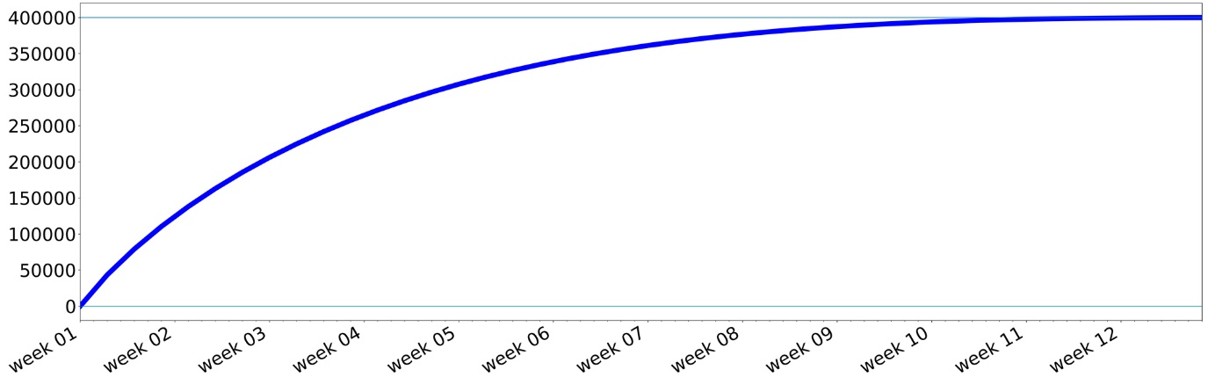

The relationship between the amount of FL tokens issued per hour and time (FL/USDFL pair):

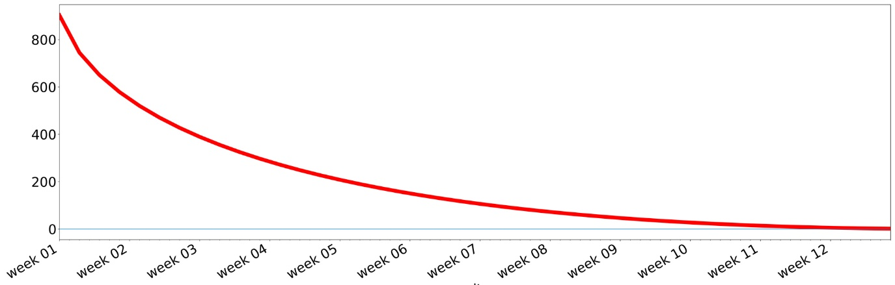

The relationship between total (cumulative) amount of issued FL tokens and time (stablecoin pairs):

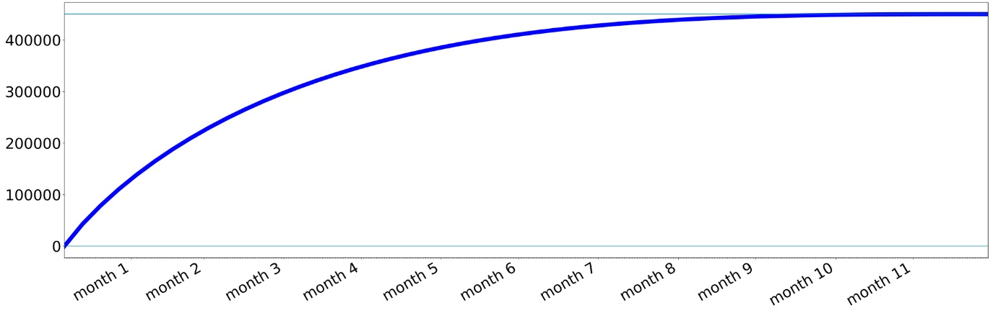

The relationship between the number of FL tokens issued per hour and time (stablecoin pairs):

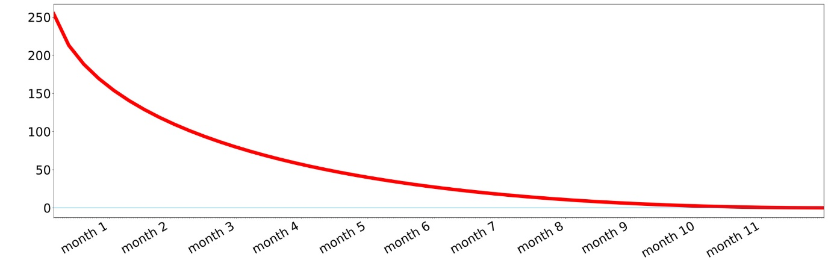

# 4. Emergency Shutdown

The emergency shutdown function is an essential part of the Freeliquid smart contract security system. This function is necessary for preventing emergency situations and is meant to protect Freeliquid user funds from cyber-attacks, malicious acts of FL token holders, and extreme market volatility. Additionally, the feature can be used during the Freeliquid Protocol upgrades to successfully implement necessary changes.

Emergency shutdown is only possible if FL holders successfully cast their votes. The Emergency Shutdown module is identical to the one of MakerDAO and is described in detail in their [documentation](https://makerdao.com/en/whitepaper/#emergency-shutdown).